EE239AS Project 3 Report
Collaborative Filtering
Student1: Xiangrui Liu (004516858) Student2: Qi Wang (604522309)
Student3: Qinyi Yan (704406413) Student4: Ziyin You (404412651)

Problem 1
To solve this problem, first, we created a matrix named R containing user ratings with users on rows and movies on columns using MovieLens dataset which consists of 100,000 ratings (1-5) from 943 users on 1682 movies. Each entry (i, j) of the matrix R is the rating that user i has given to movie j. Note that a lot of values in the matrix are missing. Entry (i, j) of the matrix is missing if user i has not rated movie j yet.
Then, we tried to run a matrix factorization to get matrices U and V such that R_{m×n}≈U_{m×k}×V_{k×n}, where matrix U represents the movie features which each user likes, matrix V represents the features of each movie, and k is the number of features we used to represent a movie. In this problem, k equals to 10, 50 and 100. To achieve the matrix factorization, we calculated matrices U and V such that the following squared error is minimized:
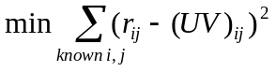
To calculate above squared error, we can replace missing entries in matrix R with 0 and create a weight matrix which contains 1 in entries where we have known data points and 0 in entries where the data is missing. Then, we transform above squared error into:
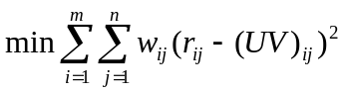
We implemented the method we mentioned above using Matrix Factorization Toolbox in MATLAB. Figure 1 shows the running result of MATLAB script. Table 1 shows the total least squared error for k equals to 10, 50 and 100.
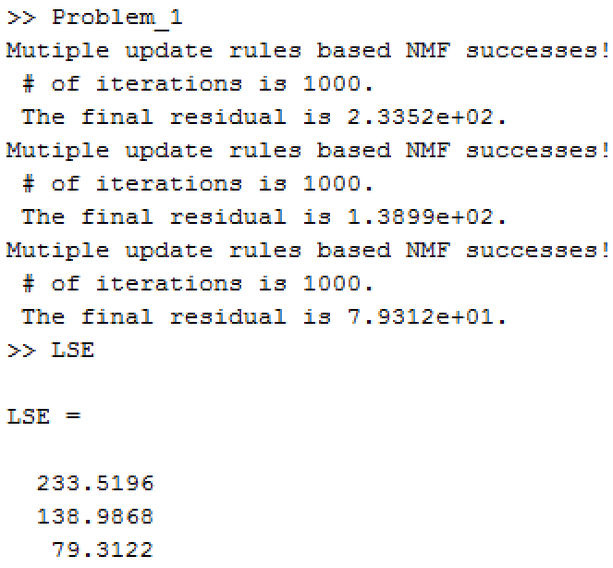
Figure 1 Screenshot of running result of MATLAB script

Table 1 Total least squared error (LSE) in each case
k | 10 | 50 | 100
Total LSE | 233.5196 | 138.9868 | 79.3122

Problem 2
In order to test the recommendation system that we have built in the problem 1, we used 10-fold cross validation. Here, we assigned an index from 1 to 100000 to all the data points. Then we created a random permutation of the integers from 1 to 100000 inclusive and then we can randomly split the data set into 10 equal parts. For each fold, we used nine of these 10 parts as training data and used the rest part as testing data. After we trained the recommendation system, we found the absolute error over the each testing data point by calculating the |R_{predicated}－R_{actual}| and then we can calculate average error for each test among all entries under different k values. Table 2 shows the corresponding results (meanError matrix in our result data). Table 3 shows the average, highest and lowest values of average error among the 10 tests.

Table 2 Average error for each test among all entries under different k values
Test # | k value
Test # | 10 | 50 | 100
1 | 2.2077 | 2.0922 | 2.2752
2 | 2.1932 | 2.0857 | 2.292
3 | 2.1895 | 2.1217 | 2.4153
4 | 2.1859 | 2.1013 | 2.3184
5 | 2.1949 | 2.1392 | 2.3017
6 | 2.1972 | 2.1147 | 2.2915
7 | 2.1992 | 2.1278 | 2.296
8 | 2.2076 | 2.0957 | 2.4164
9 | 2.1823 | 2.0951 | 2.3376
10 | 2.2138 | 2.0959 | 2.2183

Table 3 Average, highest and lowest values of average error among the 10 tests
 | k value
 | 10 | 50 | 100
Average | 2.1971 | 2.1069 | 2.31624
Highest | 2.2138 | 2.1392 | 2.4164
Lowest | 2.1823 | 2.0857 | 2.2183

Problem 3
In this problem, we assume that if a user has rated a movie 3 or lower we conclude they didn't like the movie (we used value -1 to represent “unlike” in actual values), and if a user has rated a movie 4 or higher we conclude they liked it (we used value 1 to represent “like” in actual values). Based on the estimated values in the R matrix in problem 1, we can use a threshold on the estimated entry to predict whether the user will like the movie or not. Here we tried several threshold values from 0.2 to 4.8 with a step size of 0.2. And we still used 10-fold cross validation to test new recommendation system.

In order to find out the percentage that the user actually like the movie, we calculated the precision using following formula for each case:
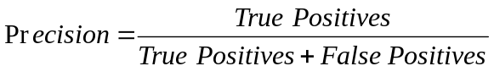
Table 5 shows the precision values under different threshold values and different k values.
Table 5 Precision under different threshold values and different k values
Threshold | k value
Threshold | 10 | 50 | 100
0.2 | 57.36 % | 57.33 % | 56.72 %
0.4 | 59.19 % | 58.88 % | 58.26 %
0.6 | 60.92 % | 60.44 % | 59.69 %
0.8 | 62.70 % | 62.05 % | 61.02 %
1.0 | 64.41 % | 63.72 % | 62.40 %
1.2 | 65.92 % | 65.16 % | 63.86 %
1.4 | 67.51 % | 66.71 % | 65.17 %
1.6 | 68.92 % | 68.12 % | 66.42 %
1.8 | 70.58 % | 69.45 % | 67.71 %
2.0 | 71.97 % | 71.00 % | 68.82 %
2.2 | 73.44 % | 72.36 % | 69.87 %
2.4 | 74.87 % | 73.68 % | 70.87 %
2.6 | 76.39 % | 74.89 % | 71.82 %
2.8 | 77.92 % | 76.19 % | 72.60 %
3.0 | 79.35 % | 77.24 % | 73.29 %
3.2 | 80.82 % | 78.38 % | 73.89 %
3.4 | 82.20 % | 79.34 % | 74.47 %
3.6 | 83.70 % | 80.16 % | 74.87 %
3.8 | 85.20 % | 80.79 % | 75.17 %
4.0 | 86.14 % | 81.32 % | 75.31 %
4.2 | 87.45 % | 81.99 % | 75.41 %
4.4 | 88.48 % | 81.97 % | 75.32 %
4.6 | 89.64 % | 81.84 % | 74.89 %
4.8 | 90.81 % | 81.24 % | 74.50 %

Figure 2 shows precision versus threshold under different k values. From Figure 2, we found that precision increases with threshold.
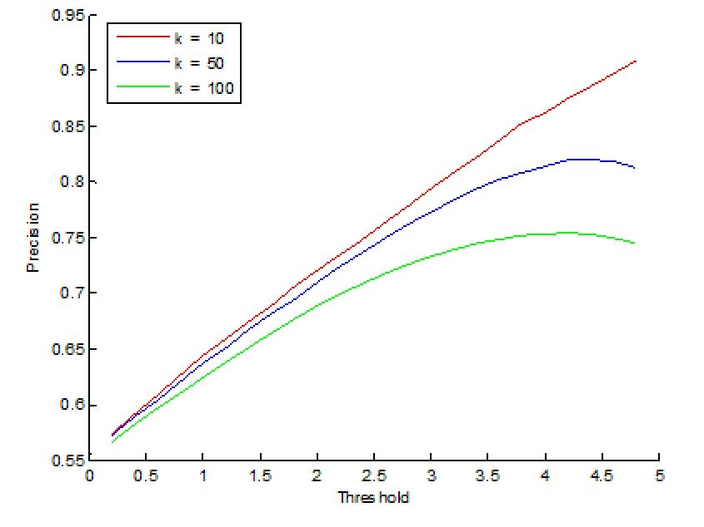
Figure 2 Precision versus threshold under different k values

In order to find out the percentage that our algorithm predict the user would like the movie, we calculated the recall using following formula for each case:
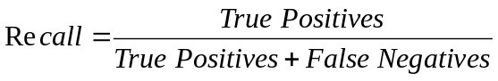
Table 6 shows the recall values under different threshold values and different k values.
Table 6 Recall under different thresholds and different k values
Threshold | k value
Threshold | 10 | 50 | 100
0.2 | 94.53 % | 90.66 % | 78.36 %
0.4 | 87.77 % | 84.38 % | 71.78 %
0.6 | 80.56 % | 78.20 % | 66.01 %
0.8 | 73.37 % | 72.21 % | 60.69 %
1.0 | 66.36 % | 66.71 % | 55.97 %
1.2 | 59.44 % | 61.13 % | 51.64 %
1.4 | 53.07 % | 55.90 % | 47.70 %
1.6 | 47.21 % | 50.93 % | 43.99 %
1.8 | 41.77 % | 46.16 % | 40.71 %
2.0 | 36.50 % | 41.86 % | 37.43 %
2.2 | 31.81 % | 37.87 % | 34.49 %
2.4 | 27.64 % | 34.23 % | 31.72 %
2.6 | 23.89 % | 30.65 % | 29.22 %
2.8 | 20.64 % | 27.31 % | 26.75 %
3.0 | 17.63 % | 24.19 % | 24.63 %
3.2 | 14.96 % | 21.52 % | 22.58 %
3.4 | 12.59 % | 18.93 % | 20.81 %
3.6 | 10.53 % | 16.70 % | 19.17 %
3.8 | 8.75 % | 14.57 % | 17.72 %
4.0 | 7.26 % | 12.66 % | 16.36 %
4.2 | 5.91 % | 11.03 % | 15.10 %
4.4 | 4.71 % | 9.56 % | 14.01 %
4.6 | 3.75 % | 8.21 % | 12.95 %
4.8 | 2.93 % | 7.10 % | 12.02 %

Figure 3 shows recall versus threshold under different k values. From Figure 3, we found that recall decreases with threshold.
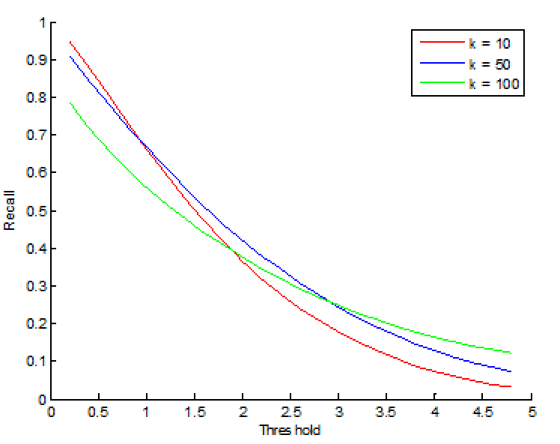
Figure 3 Recall versus threshold under different k values

Figure 4 shows precision versus recall for different values of the threshold for the designed recommendation system. Figure 5 shows the ROC curve (True positive rate versus False positive rate).
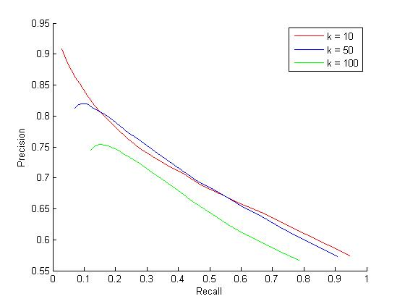
Figure 4 Precision versus recall under different k values

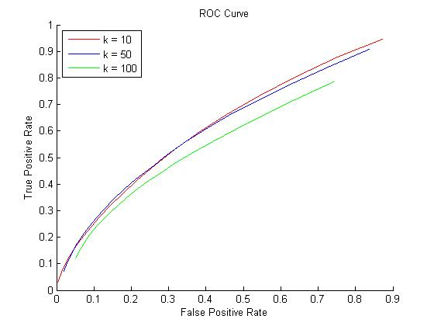
Figure 5 The ROC curve

Problem 4

Problem 5

